The Mid-Michigan Health Impact Assessment Toolkit
It is increasingly recognized that many programs and policies once considered incidental to (or even separate from) health can have profound health consequences for local populations. These include community development, such as land use and housing, design of the built environment, and transportation. The potential impacts on human health and wellbeing go far beyond the basic safety concerns or regulatory requirements.
Health Impact Assessment (HIA) is been described as “ . . . a structured process that uses scientific data, professional expertise, and stakeholder input to identify and evaluate public-health consequences of proposals and suggests actions that could be taken to minimize adverse health impacts and optimize beneficial ones.” (National Research Council, Improving Health in the United States, 2011)
The Mid-Michigan Program for Greater Sustainability (MMPGS) recently announced a new online HIA and planning support toolkit for Clinton, Eaton, and Ingham Counties, which is shown in the figure below. The HIA Toolkit is available on the MMPGS Portal at: http://www.midmichigansustainability.org/.
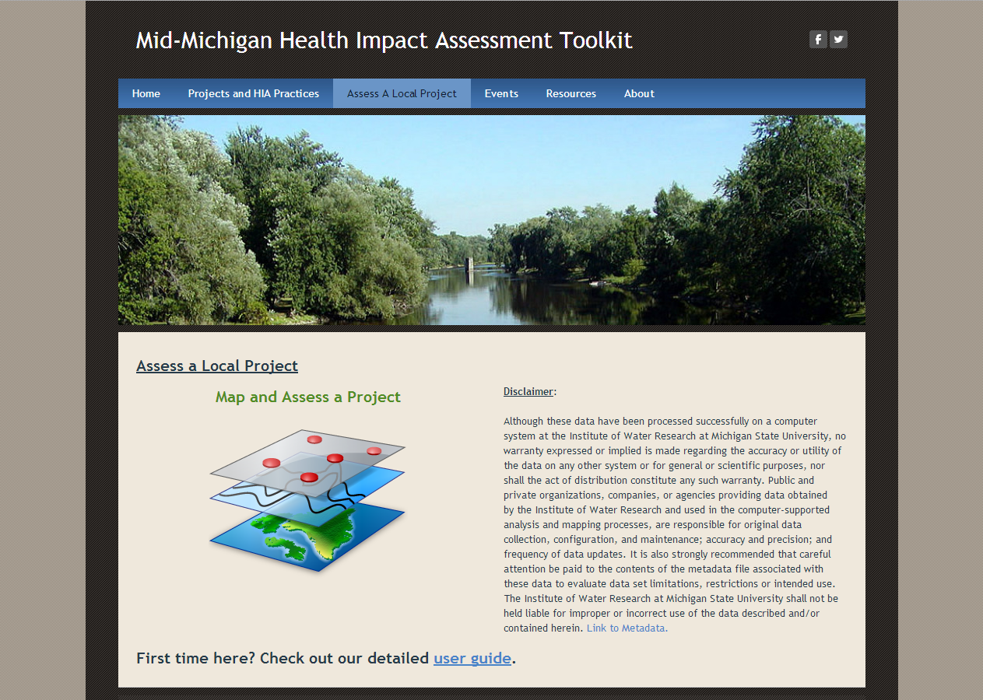
The free, online mapping and analysis toolkit (shown in the next figure) supports communities in completing health impact assessments of policies and changes to the built environment. The toolkit provides local leaders, community planners, landowners, developers, and the public with the ability to locate a construction or development project on an interactive map and assess the impacts that the respective development may or may not have on public health. Examples include assessing the project’s access to public transit lines or sidewalks; its proximity to grocery stores, schools and parks; its impact on local rivers and streams, on noise levels; and much more. The toolkit is based, in part, on Meridian Township’s voluntary and successful HIA Checklist, which has been in use since 2006, helping landowners and developers with the permit application and review process.
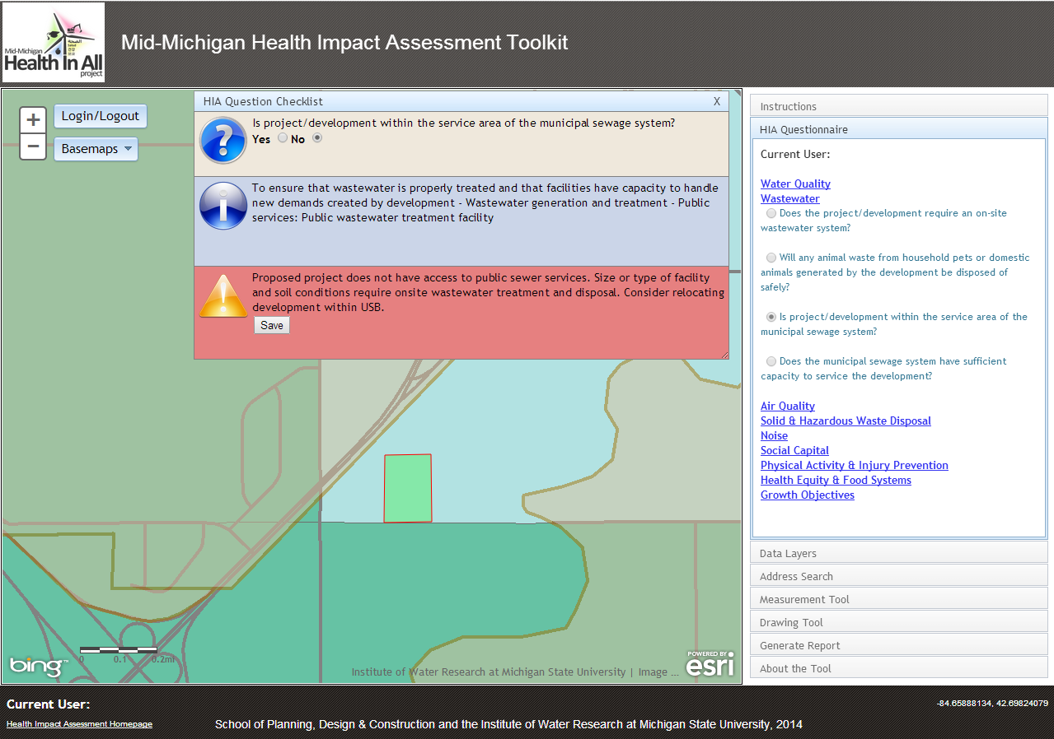
A detailed user guide is provided on the MMPGS Portal. Training in the use of the toolkit for planners, community officials, government agencies, developers, and the public is available from the Tri-County Regional Planning Commission and Michigan State University. Organizations interested in learning more about the HIA Toolkit and training opportunities can contact
Dr. Michael R. Thomas at: thomasmr7@comcast.net or call 517-332-2986. Comments and suggestions for improving the tool are welcome.
The U.S. Department of Housing and Urban Development’s Sustainable Communities program and the Robert Wood Johnson Foundation and Pew Charitable Trust Health Impact Project provided funding for this project. Project participants include the three county health departments, Tri-County Regional Planning Commission and MSU’s School of Planning, Design, and Construction and the Institute of Water Research.

